- In a web browser, go to Myxc.org
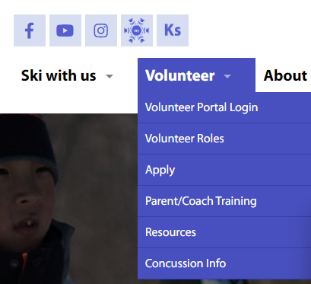
- Go to the Volunteer section (upper left) and select Volunteer Portal Login from the drop down
- On the next page, enter your login credentials from last year. If you don’t remember them, there is a “Forgot password” option below the login.

- Once logged you will be asked to go through a brief application and training (this is done every year for every volunteer). There are pages 1-15 that you can read through to review. Once finished, SCROLL DOWN for the questions:

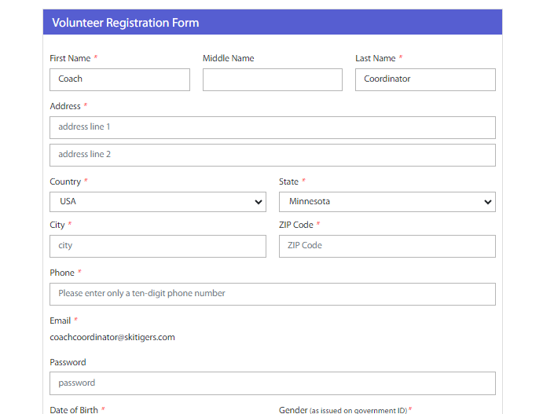
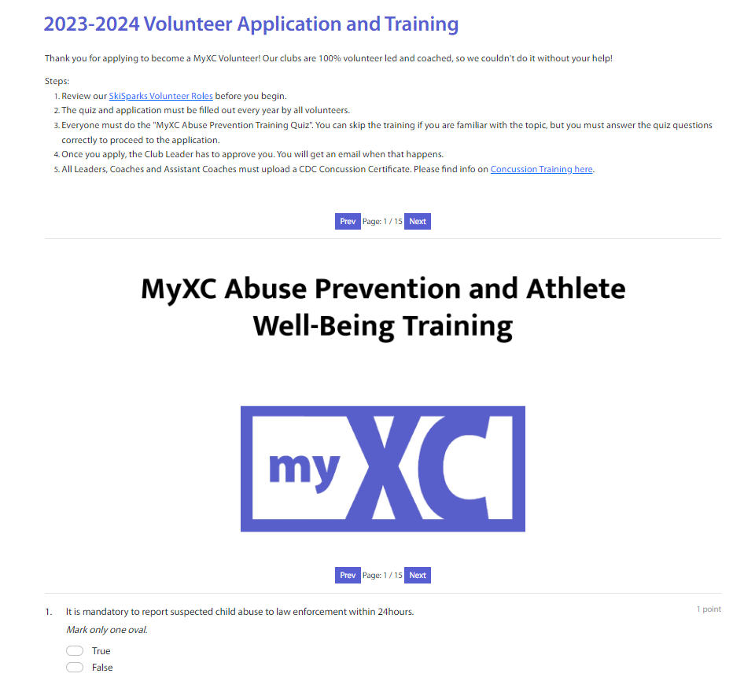
- Re-enter or update your volunteer information on the next page, if requested.

- If you volunteered last year, this would be your second year. Choose “Copper Country Ski Tigers” as your club and the volunteer role you’d like for this season.
- ****We need volunteers to make Ski Tigers work but if you DON’T want to volunteer and just want to register your skier, you need to uncheck the “I would like to volunteer as a: “ below (see red circle) If you do this, you will not see most of the dropdowns that follow on the page.
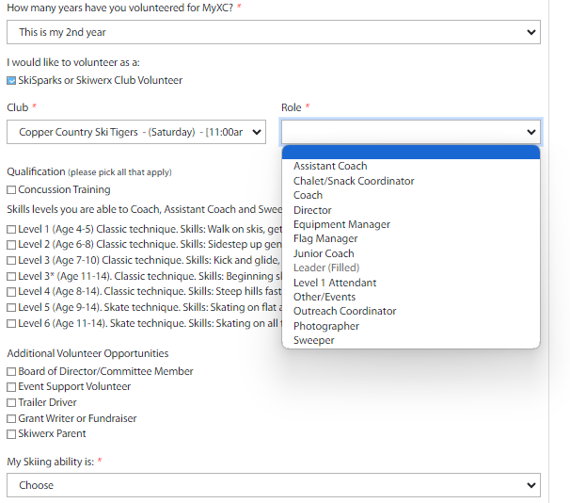

- If you choose to volunteer as a Coach, Assistant Coach or Sweep role (THANK YOU!) select all the skill levels you are comfortable with helping with on skis.
- Select your skiing ability, regardless of your volunteer role, if you ski.
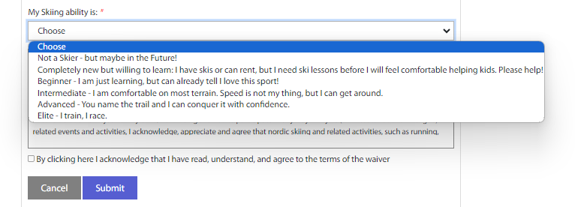
- Once you complete the registration you may be asked to login again:
- You can now register your skier(s):
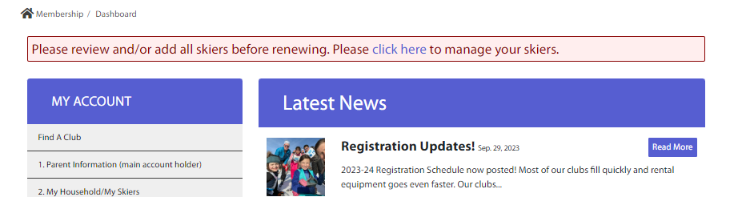
- Add a skier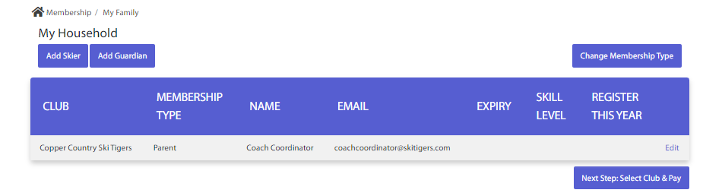

- Complete the Skier information (see below & 13.) Please fill in the school and grade, if it auto-fills incorrectly.
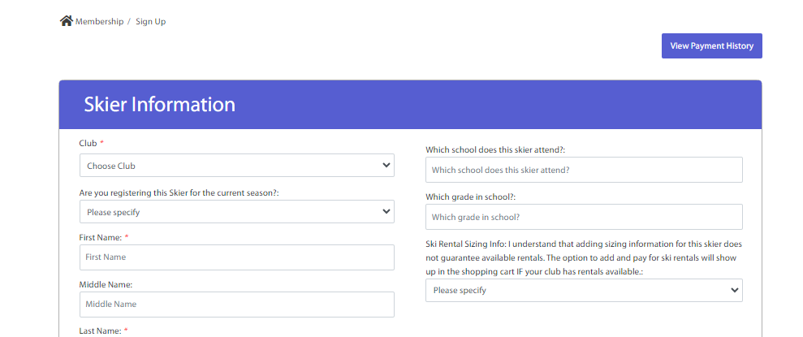
- The information about “First Time Skiing (yes/no)” and “First Winter with MyXC (yes/no)” will cause the skill level to populate differently for different answers.

Please read these questions as:
First time skiing? – is this a beginner skier? If not, please answer “no”
First Winter with MyXC? – If your skier has been on skis on trails with Ski Tigers, other clubs or just playing around with family while on skis, please answer “no”.

Don’t worry if you get the wrong skill level for your skier, they will be evaluated the first time out on skis, regardless of the level they are put into.

- Rentals (last question on the registration) – Ski Tigers has classic and skate skis for rent for all levels of skiers on a first come, first served basis. Our fee is $50 for the season with $25 deposit returned at the end of the season upon the rental return. You will need the height, weight and boot size of the skier(s) who will be renting skis.

- Once you have registered a skier you will come to a “Membership Registration” page. Select “Update your skiers” to add a skier(s) or to get to the payment portion of the registration.

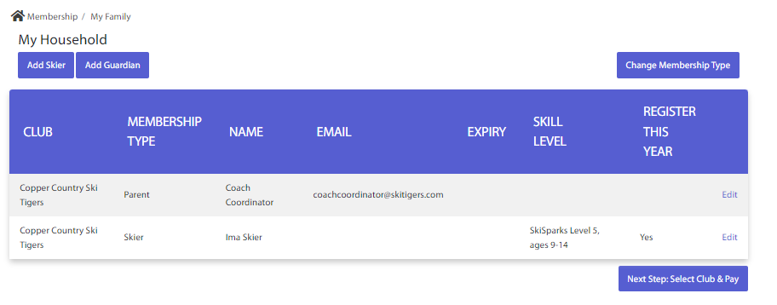

Any questions, please email: registrar@skitigers.com

